Lab Assignment -2
Q.1> Molecular Dynamics
Metric | Observation | Impact on efficiency
CPU Utilization | Increased with threads from 0.835 to 2.05 | Better parallel usage of cores
CPI | Increased from 0.18 to 0.30 | More memory stalls and synchronization
Time | Decreased significantly | Speedup due to parallelization
Page Faults | Increased from 77 to 1875 | Larger memory pressure at higher threads
Bandwidth | Increased from 1.7 to 3.5 GB/s | Memory subsystem saturation
Vectorization | 0% | Scalar execution limits peak performance
In this table we are only using the best times and speedup from all type of scheduling used in the program.
Threads (N) | Time (s) | Speedup (S) | Efficiency (S/N) | Page Faults
1 | 0.363 | 1.0 | 100% | 77
2 | 0.197 | 1.88 | 94% | 237
4 | 0.119 | 3.07 | 76% | 471
8 | 0.087 | 4.24 | 53% | 940
16 | 0.084 | 4.99 | 31% | 1878

Scheduling Comparison :
Threads | Static | Dynamic | Guided | Best
1 | 0.363 | 0.390 | 0.361 | Guided
2 | 0.285 | 0.197 | 0.274 | Dynamic
4 | 0.164 | 0.119 | 0.167 | Dynamic
8 | 0.115 | 0.087 | 0.122 | Dynamic
16 | 0.091 | 0.084 | 0.080 | Guided
Observation:
Dynamic/guided outperform static due to better load balancing of pairwise interactions.
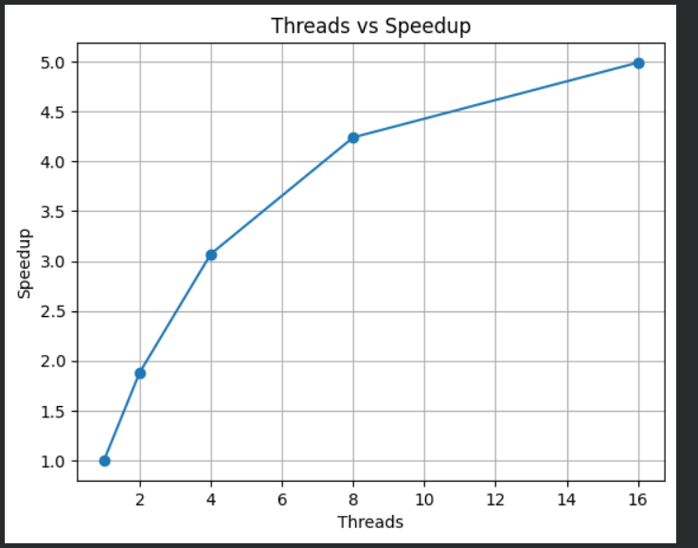

The Lennard–Jones molecular dynamics kernel demonstrates good parallel scalability initially, but the performance improvement gradually stagnates as the number of threads increases beyond 8–16. Although execution time decreases significantly when moving from a single thread to multiple threads, the achieved speedup is clearly sub-linear and overall efficiency drops at higher thread counts. This behavior arises from several interacting hardware and algorithmic limitations including workload imbalance, memory bandwidth saturation, cache coherence overhead, false sharing, and thread management costs. The pairwise force computation follows a triangular iteration pattern where each outer-loop index performs a decreasing number of interactions. Consequently, early iterations involve substantially more work than later ones. Under static scheduling, this uneven workload distribution causes some threads to finish earlier and remain idle while others continue computing, leading to poor utilization and reduced scalability. Dynamic and guided scheduling alleviate this issue by redistributing work at runtime, improving load balancing and ensuring that threads remain active, which explains their consistently better performance compared to static scheduling.
Despite improved load balancing, scalability is still limited primarily by memory behavior. The Lennard–Jones force calculation has low arithmetic intensity because each interaction requires multiple memory loads and stores for particle positions and forces but performs relatively few floating-point operations. As a result, the kernel is memory-bound rather than compute-bound. When more threads execute concurrently, they simultaneously access the shared position and force arrays, increasing contention for the memory subsystem. VTune measurements show increasing memory bandwidth utilization and CPI with thread count, indicating that cores spend more cycles stalled waiting for data rather than performing useful computation. Once the available DRAM bandwidth is saturated, adding additional threads cannot further reduce execution time, which leads to the flattening of the speedup curve.
Additional performance degradation occurs due to cache coherence effects. Although thread-local buffers are used during force accumulation, the final updates still write into shared force arrays. Multiple threads updating nearby elements cause cache lines to frequently migrate between cores under the MESI protocol, creating coherence traffic and increasing memory latency. Moreover, since force arrays are contiguous in memory, adjacent indices often lie on the same cache line. When different threads update these neighboring elements, false sharing occurs, resulting in unnecessary cache invalidations even though the data is logically independent. This further increases stalls and reduces throughput. At higher thread counts, OpenMP runtime overhead, synchronization barriers, and occasional context switching also become significant, especially when the number of threads approaches or exceeds the number of physical cores. These overheads reduce the effective parallel fraction of the program.
The observed rise in page faults with increasing threads further indicates growing memory pressure and reduced locality. Larger working sets cause more TLB misses and higher access latency, which contributes to the increasing CPI and declining efficiency. Collectively, these effects explain why the speedup improves rapidly at small thread counts but eventually saturates instead of scaling linearly. According to Amdahl’s Law, the serial components and parallel overheads impose a hard limit on the maximum achievable acceleration. Therefore, beyond a certain point, the additional cost of contention and synchronization outweighs the benefits of extra threads. Overall, the Lennard–Jones simulation benefits significantly from OpenMP parallelization, with dynamic scheduling providing the best load balancing, but the kernel remains fundamentally memory-bound and communication-heavy. The optimal performance is achieved around 8 threads, after which efficiency declines due to bandwidth limitations, cache coherence overhead, and thread contention.
Q.2> Bioinformatics - DNA Sequence Alignment (Smith-Waterman)
Metric | Observation | Impact on efficiency
CPU Utilization | Increased with threads from 0.94 to 1.391 | Better parallel usage of cores
CPI | Increased from 0.558 to 1.531 | More memory stalls and synchronization
Time | Increased from 0.299 to 1.36 | Parallel overhead exceeds benefit
Page Faults | Low but TLB misses high | Large matrix causes address translation overhead

Benchmark Results – Static Scheduling
Threads (N) | Execution Time (s) | Speedup (S) | Efficiency (E=S/N) | Page Faults
1 | 0.299 | 1.0 | 100% | 47
2 | 0.753 | 0.39 | 19% | 26
4 | 0.862 | 0.33 | 8% | 36
8 | 1.316 | 0.21 | 2.7% | 63

Benchmark Results – Dynamic Scheduling
Threads (N) | Execution Time (s) | Speedup (S) | Efficiency (E=S/N) | Page Faults
1 | 0.341 | 1.0 | 100% | 0
2 | 0.638 | 0.53 | 26% | 0
4 | 0.739 | 0.46 | 11% | 0
8 | 1.152 | 0.3 | 3.7% | 0

Benchmark Results – Guided Scheduling
Threads (N) | Execution Time (s) | Speedup (S) | Efficiency (E=S/N) | Page Faults
1 | 0.302 | 1.0 | 100% | 0
2 | 0.563 | 0.54 | 27% | 0
4 | 0.709 | 0.43 | 10% | 0
8 | 1.151 | 0.26 | 3.2% | 0

Graph for static similar patter will be observed for others too
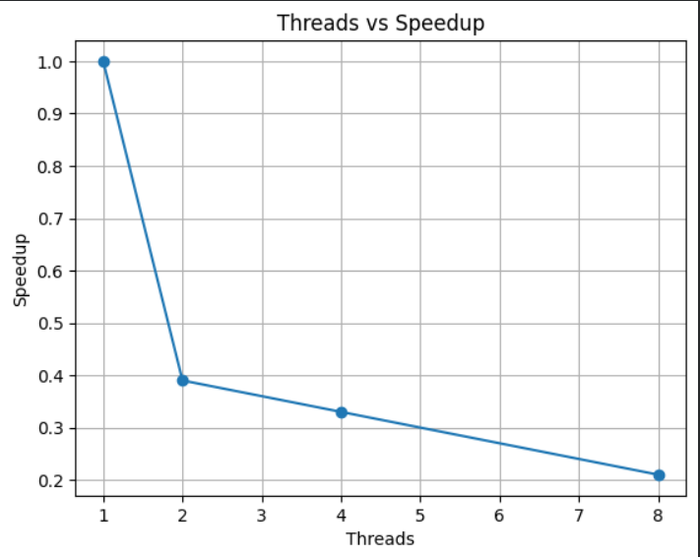
The Smith–Waterman local sequence alignment kernel exhibits limited parallel scalability under wavefront parallelization, with performance improvements observed only at very small thread counts and gradual degradation as additional threads are introduced. Although the anti-diagonal (wavefront) strategy ensures correctness by respecting dynamic programming dependencies, the achieved speedup remains sub-linear and efficiency drops sharply beyond 2–4 threads. This behavior results from several inherent algorithmic and architectural constraints including limited instantaneous parallelism, frequent synchronization barriers, memory bandwidth saturation, cache and TLB overheads, and OpenMP runtime costs.
The fundamental limitation arises from the structure of the dynamic programming dependency graph. The number of cells that can be computed concurrently equals the length of each anti-diagonal, which grows gradually, peaks near the center of the matrix, and then decreases symmetrically. Consequently, a large portion of the execution consists of short diagonals containing very few independent cells. During these phases, only a small subset of threads can perform useful work while the remaining threads remain idle, causing poor core utilization and significant load imbalance. Furthermore, each diagonal introduces an implicit synchronization barrier, forcing all threads to wait before progressing to the next step. The cumulative cost of thousands of such barriers dominates the runtime and offsets the benefits of parallel execution.
Even when sufficient parallel work exists, scalability is further constrained by memory behavior. The Smith–Waterman update for each cell performs multiple memory loads and stores while executing only a small number of arithmetic operations, resulting in low computational intensity. As a result, the kernel is memory-bound rather than compute-bound. With increasing thread counts, multiple cores simultaneously access the large scoring matrix, leading to contention for cache capacity and main memory bandwidth. VTune analysis confirms rising CPI, high memory-bound stalls, and substantial DTLB overhead, indicating that processors spend more time waiting for memory accesses than performing useful computation. Once the available memory bandwidth is saturated, additional threads provide negligible performance benefit.
Cache and translation effects further contribute to performance degradation. The large matrix footprint exceeds cache capacity, causing frequent cache misses and poor spatial locality. Additionally, the working set spans many memory pages, increasing TLB miss rates and triggering costly page walks. These translation overheads grow with thread count as more cores traverse memory concurrently, amplifying latency and reducing throughput. Combined with OpenMP scheduling overhead and thread management costs, these factors significantly reduce the effective parallel fraction of the application.
Overall, although wavefront parallelization enables safe concurrent computation, the Smith–Waterman algorithm remains fundamentally constrained by synchronization frequency and memory limitations. According to Amdahl’s Law, the serial portions and parallel overheads impose a strict upper bound on achievable speedup, causing the performance curve to flatten or even degrade beyond a small number of threads. Consequently, the best performance is typically achieved with only a few threads, while higher thread counts lead to diminishing returns. More scalable performance would require higher-level optimizations such as blocked (tile-based) wavefront processing, improved cache locality, reduced synchronization, or memory footprint reduction.
Q.3> Scientific Computing - Heat Diffusion Simulation
Performance Results
Metric | Observation | Impact on Efficiency
CPU Utilization | Increased from ~11% (1 thread) to ~37% (8 threads) but never reached full core usage | Partial core usage limits achievable speedup
CPI | Increased from 0.31 to0.72 as threads increased | More stalls due to memory latency and bandwidth contention
Execution Time | Decreased initially (8.6s to 4.6s) but improvement slowed beyond 4–8 threads | Diminishing returns from extra threads
DRAM Bandwidth | Approached 75–80% utilization at higher threads | Bandwidth saturation prevents further speedup
Cache Behavior (L3 Bound) | Increased significantly with threads | More cache misses and coherence traffic
DTLB/TLB Misses | Noticeable translation overhead | Large grid increases page walk latency

Threads | Schedule | Time (s) | Speedup | Efficiency | Page Faults
1 | Serial Baseline | 8.611 | 1.0 | 100% | 43
2 | Static | 4.808 | 1.7207 | 86% | 27
2 | Dynamic | 4.678 | 1.7685 | 88% | 0
2 | Guided | 4.665 | 1.7734 | 89% | 0
4 | Static | 4.76 | 1.7456 | 44% | 38
4 | Dynamic | 4.482 | 1.8539 | 46% | 0
4 | Guided | 4.322 | 1.9225 | 48% | 0
8 | Static | 4.519 | 1.8584 | 23% | 64
8 | Dynamic | 3.86 | 2.1756 | 27% | 0
8 | Guided | 4.043 | 2.0772 | 26% | 0

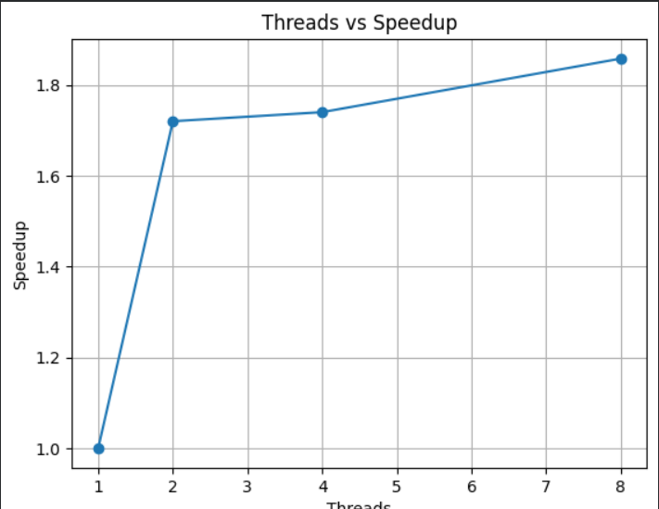

Conclusion
The 2D heat diffusion simulation demonstrates good initial parallel scalability because each grid cell update depends only on the previous timestep, allowing independent and race-free computation across the spatial domain. This results in near-linear speedup when increasing from one to two threads. However, scalability becomes sub-linear as the number of threads grows.
The stencil computation has low arithmetic intensity, requiring multiple memory loads and stores for each update while performing few floating-point operations. Consequently, the kernel is memory-bound rather than compute-bound. VTune analysis shows increasing memory-bound stalls, DRAM bandwidth saturation, cache misses, and store latency at higher thread counts. Once memory bandwidth becomes the bottleneck, additional threads cannot significantly reduce execution time, leading to diminishing returns and reduced efficiency.
Dynamic and guided scheduling slightly outperform static scheduling by improving load balancing, although the workload is already fairly uniform. Ultimately, performance is constrained primarily by the memory hierarchy rather than computational limits. Therefore, optimal performance is achieved at moderate thread counts, while further scaling requires memory-focused optimizations such as loop tiling, cache blocking, and improved data locality rather than simply increasing parallelism.

